CHAPTER 8: The dynamic Earth
Worksheet 8.6

Volcanic activity
Answers

Steep-sided volcanoes
1. The diagram shows a steep-sided volcano forming as a result of tectonic activity.
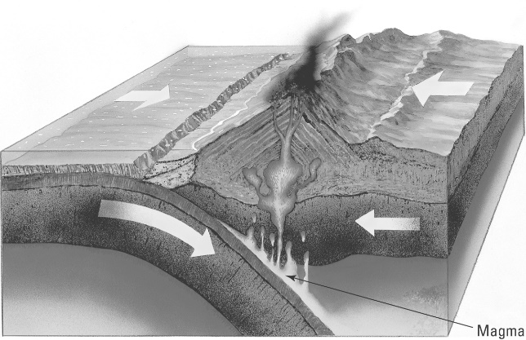 | (a) Identify the type of plate boundary that leads to the formation of the volcano.  Subduction zone  (b) Explain why the oceanic crust melts to form magma.  Frictional heating  (c) Identify a location in the southern hemisphere where such an event occurs.  West coast of South America

Eruption
2. The following events describe the eruption of a steep-sided volcano. The events are jumbled. Rearrange the letters A–F to arrange the events in the correct sequence.
A. Magma rises towards the surface.
B. Lava is blasted into the air.
C. The expanding gases cause an explosion that rips open the vent.
D. Ash, cinders and dust rain down onto the ground.
E. Low-density magma rises under pressure into the magma chamber.
F. Dissolved gases expand as the magma rises.
E, A, F, C, B, D
Answer:
Our volcanic neighbours  3. The diagram below shows the region north and east of Australia. Volcanoes are marked on the map.  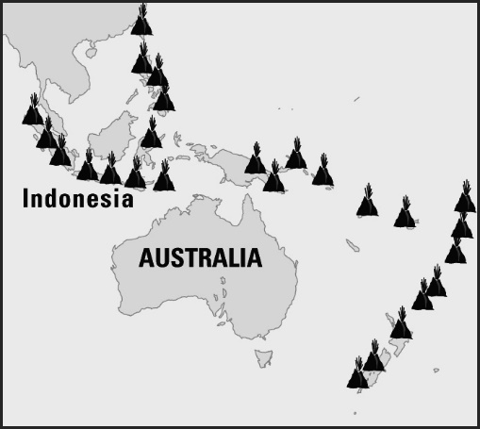  © MAPgraphics, Pty Ltd, Brisbane | (a) Explain why the volcanoes are located in these places.  The volcanoes are present along the boundaries of plates. These plate boundaries are subduction zones.  (b) Explain why there are no active volcanoes in Australia.  Australia does not lie near the edge of a plate (the Indo-Australian plate). We have a small number of earthquakes. However, since the continent is a long way from a subduction zone or a slip-strike zone, volcanoes do not form.

